

Programming Fundamentals

Student Name :MOMIN HAYAT KHAN

Roll No: S20-0273

Department :BS(Artificial Intelligence)

Batch / Year:SPRING 2020

Lecturer: Mam Misbah

Assignment No # 02

Program No 1:

|  |
| --- |
| #include <iostream>  using namespace std;  int main()  { int Num1,Num2,Num3;  cout<<"Input the value of Number 1= ";cin>>Num1;  cout<<"Input the value of Number 2= ";cin>>Num2;  cout<<"Input the value of Number 3= ";cin>>Num3;  if (Num1>Num2 && Num1>Num3)  {cout<<"Number 1 is greater";}  else if (Num2>Num1 && Num2>Num3)  {cout<<"Number 2 is greater";}  else if (Num3>Num2 && Num3>Num1)  {cout<<"Number 3 is greater"; } } |

Output:

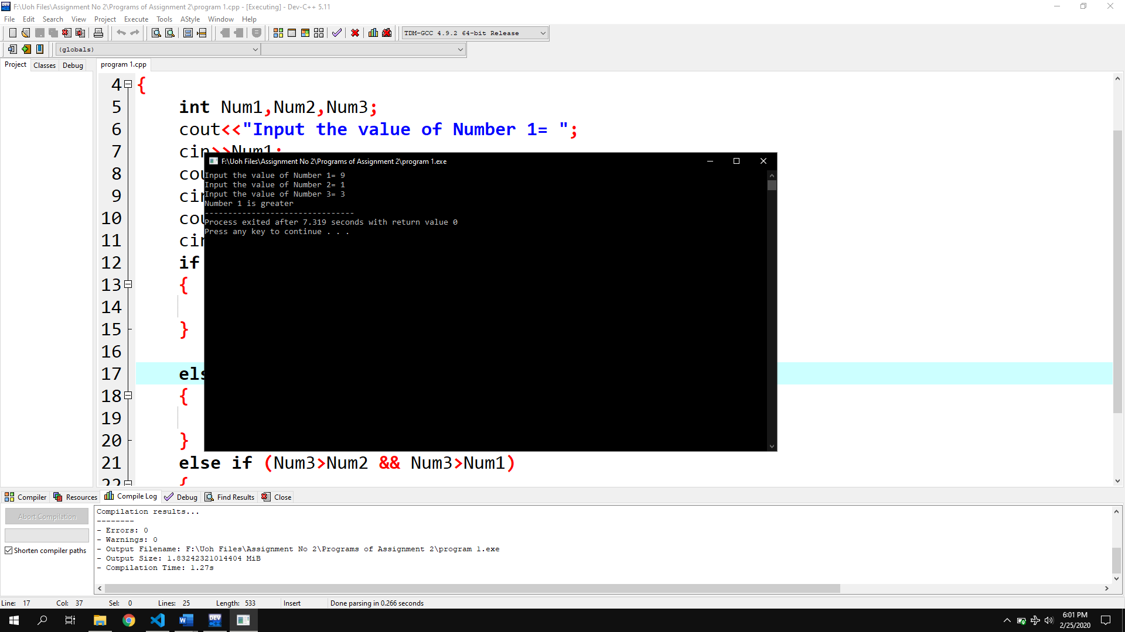

Program 2:

|  |
| --- |
| #include <iostream>  using namespace std;  int main()  { int marks;  cout<<"Entered marks to check the grade= ";cin>>marks;  if (marks<=100)  { if(marks>=90){cout<<"you got grade A";}  else if(marks>=80){cout<<"you got grade B";}else if (marks>=70)  {cout<<"you got grade C";}  else if (marks>=60){cout<<"you got grade D";}else if(marks>=0)  {cout<<"you got grade F";}}  else  {cout<<"you entered invalid marks";}  } |

Output:

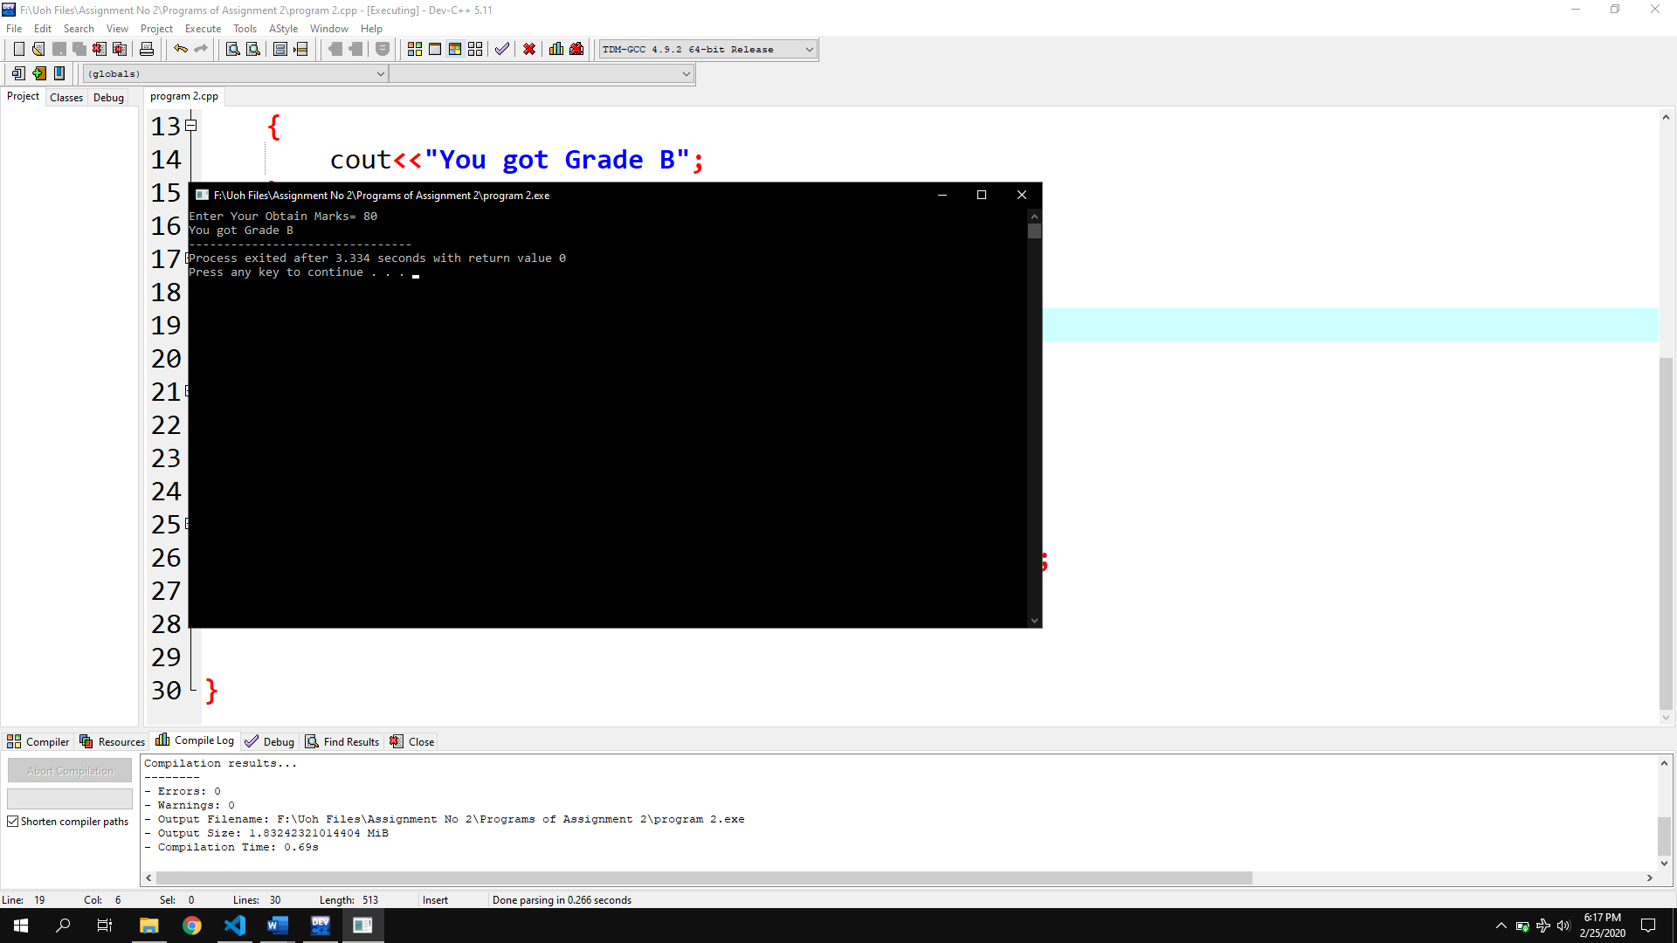

Program No 3:

|  |
| --- |
| #include <iostream>  using namespace std;  int main()  { char A_Character;  cout<<"Enter a character= ";cin>>A_Character;  if (A_Character=='a' || A_Character=='e' || A_Character=='i' ||A_Character=='o' || A_Character=='u' || A_Character=='A' || A_Character =='E' || A_Character=='I' || A_Character=='O' || A_Character=='U')  {cout<<"It is a Vowel";}  else  {cout<<"It is a Consonant";}} |

Output:

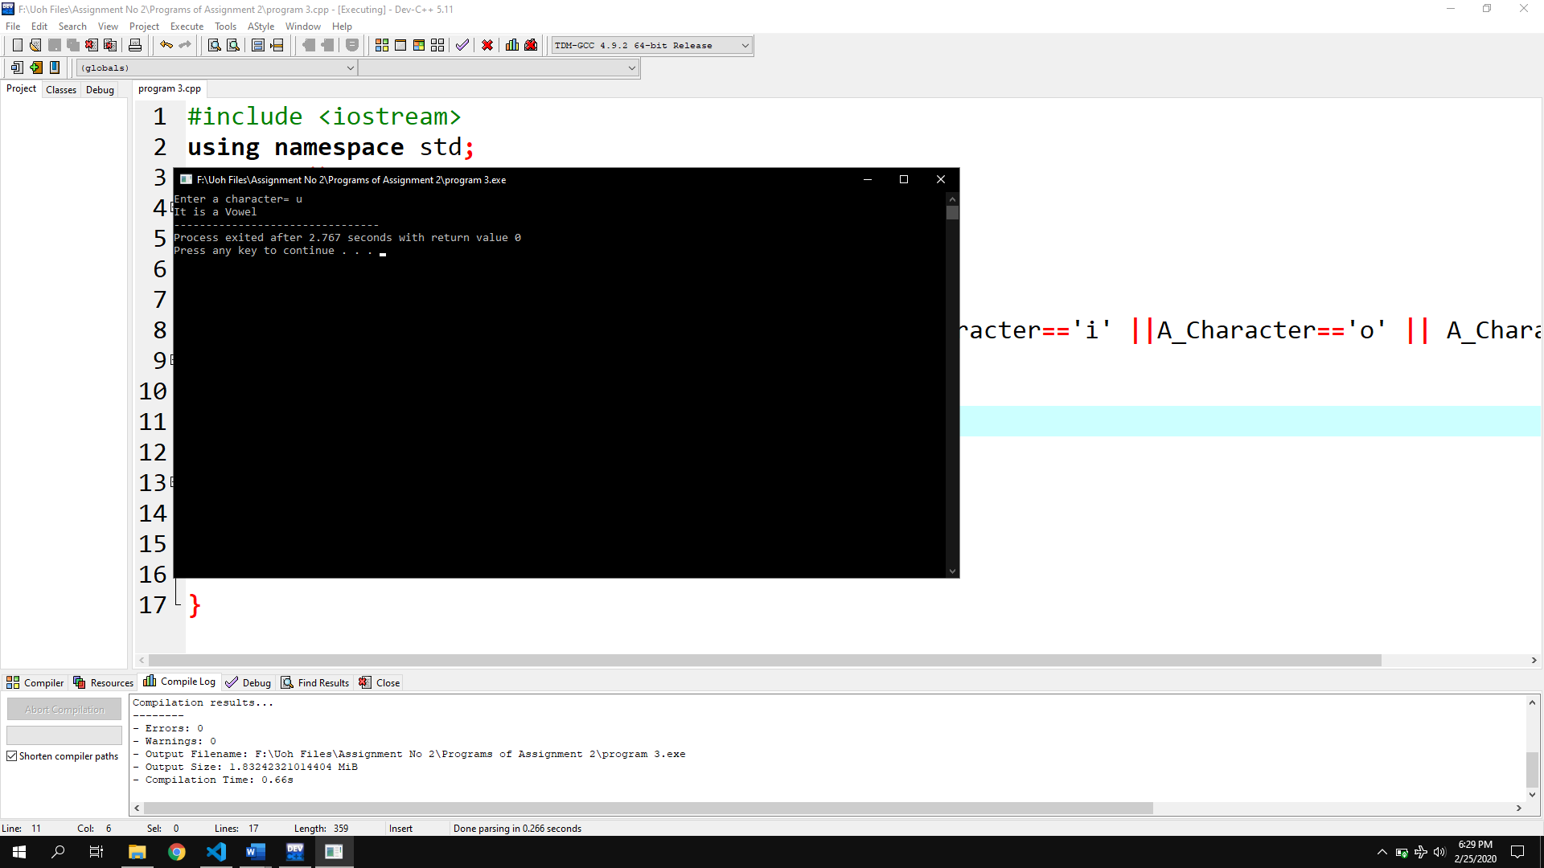

Program No 4:

|  |
| --- |
| #include <iostream>  using namespace std;  int main()  { int A_Var;  cout<<"Enter an Integer to check is its Even or Odd= ";cin>>A_Var;  if (A_Var%2==0)  cout<<"The Number is Even";  else{cout<<"The Number is Odd";}} |

Output:

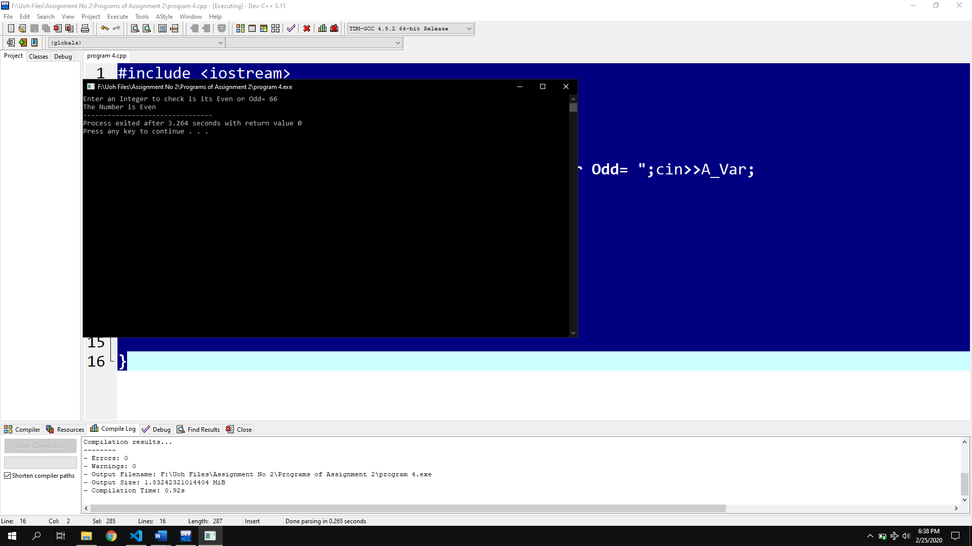

Program No 5(With ASCII code):

|  |
| --- |
| #include <iostream>  using namespace std;  int main()  { char ch;  cout<<"Enter the Alphebet ";cin>>ch;  if (ch>=65 || ch>=97)  { if(ch<=90)  {cout<<"Entered letter is Capital";}  else  {cout<<"Entered letter is Small";}}  else  {cout<<"invalid num entered";}} |

Program 5 (With Character Method):

|  |
| --- |
| #include <iostream>  using namespace std;  int main ()  {  char ch;  cout<<"Input Character =";cin>>ch;  if (ch>='A' || ch<='Z' || ch<='a' || ch<='z')  {  if (ch<='A' || ch<='Z')  {  cout<<"You Entered Capital Character ";  }  else if (ch>='a' || ch<='z')  {cout<<"You Entered Small Character ";} } } |

Output:

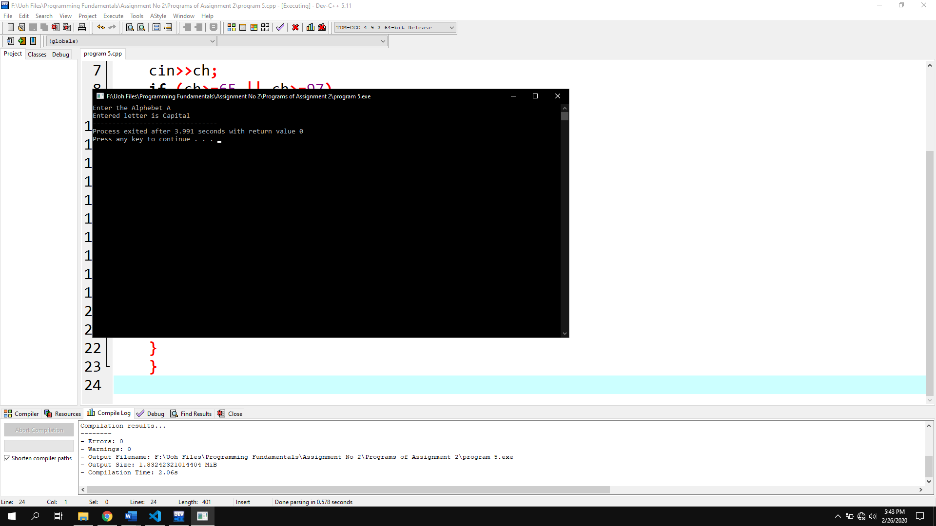

Program No 6:

|  |
| --- |
| #include <iostream>  using namespace std;  int main()  { int temp;  cout<<"Enter the temperature= ";cin>>temp;  if (temp<=0)  {cout<<"It is ICE";}  else if (temp>0 && temp<100)  {cout<<"It is Water";}  else if (temp>=100)  {cout<<"It is STREAM";}} |

Output:

